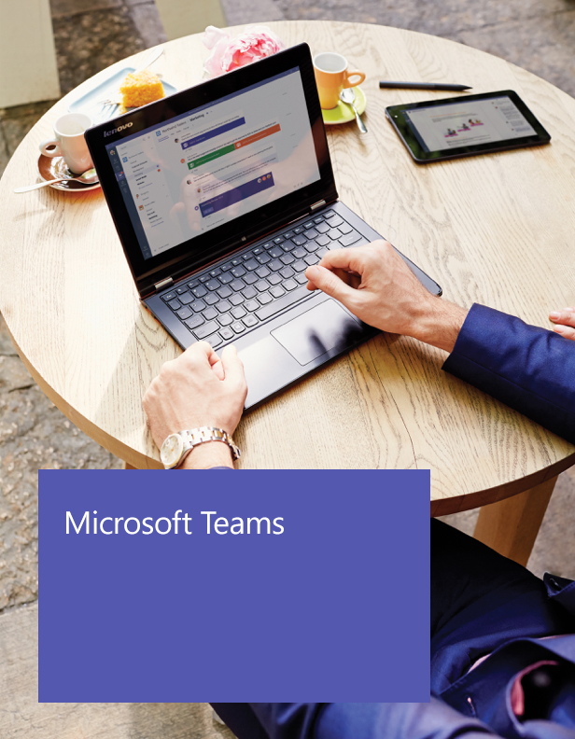

IT Admins

Getting started with Microsoft Teams

Microsoft Teams makes it easier to work together and get things done by bringing together group chat, content, and everyday tools in an open, informal team environment.

Welcome, we’re glad you’re here!

This guide is designed to help you launch and make the most of Microsoft Teams. As an Office 365 Admin of Microsoft Teams, you play a critical role in the successful deployment, adoption, and ongoing usage of Microsoft Teams across your organization.

It’s easy to get started!

Roll out Microsoft Teams across your organization by following the steps outlined in this guide. It includes all the resources you need to be successful.

1. Understand Microsoft Teams
2. Deploy Microsoft Teams
3. Launch pilot teams
4. Launch organization-wide

You can also take advantage of our FastTrack service for personalized remote assistance in rolling out Microsoft Teams. [Go to FastTrack](http://fasttrack.microsoft.com)

Join the Microsoft Teams Tech Community to discover and share best practices and tips with other IT Pros.

<https://aka.ms/msteamscommunity>

1. Understand Microsoft Teams

Core Values

Microsoft Teams is designed for teams that work closely together to get things done:

* Share info and updates in the open to stay in the know
* Rely on team discussion and support making quick decision on the fly
* Collaborate on projects and tasks, including content and deliverables

Microsoft Teams is the chat-based workspace in Office 365. It is one collaboration service in Office 365 that addresses the unique needs and challenges of working in teams. Because company needs around collaboration are unique, there is not one size fits all. Companies rely on one, two, or multiple applications in Office 365, such as Outlook, SharePoint, Skype for Business, and Yammer to meet different needs of working together.

Differentiators

Being part of Office 365 means Microsoft Teams comes with built-in integrations to Azure Active Directory, SharePoint, OneNote, Office 365 Groups, and more. This allows you to maximize your Office 365 investments, while providing a simple and secure user experience across tools.

Office 365 has strong commitments around security, compliance, privacy, and transparency. Microsoft Teams was built using these same principles to deliver an enterprise grade platform.

From the start, Microsoft Teams was architected with compliance, authentication, and privacy in mind. Microsoft Teams will have compliance built-in, with support for industry standards including ISO 27001 and 27018, SOC 1 and SOC 2, HIPPA, EU Model Clauses, and more.

Microsoft Teams protects team data securely using strong security measures including two factor authentication, hard passwords, and access policies. Your data is encrypted, whether it is chat, notes, or files. It’s your data, you own it, you control it. Microsoft does not mine customer data for advertising purposes and we safeguard customer data with strong contractual commitments.

In keeping with our commitment to provide customers the utmost transparency, customers can see uptime, the location of their data, and detailed reports of how Office 365 controls map to the security, privacy, compliance, and risk management controls defined in the Cloud Security Alliance Cloud Control Matrix (CSA CCM).

Microsoft Teams is enterprise grade, with support in 18 languages across 181 markets and 6 data centers worldwide, a 99.9% financially backed SLA and 24/7 support.

Definitions

Organization

All teams created by employees in your organization are associated with your Office 365 tenant. You can designate all employees or a subset of employees with the ability to create teams, using Office 365 Groups.

**Team**

A team is designed to bring together a group of people that work closely to get things done. Teams can be dynamic for project-based work (e.g. launching a product, creating a digital war room), as well as ongoing, to reflect the internal structure of your organization (e.g. departments and office locations). Conversations, files, and notes across team channels are only visible to members of the team.

Channel

A channel helps organize the team’s conversations, content, and tools around a specific topic. Channels can be organized, for example, by topic (events), discipline (design), project (launch), or just for fun (fun stuff). Team owners can create channels, and enable team members with the ability to create channels, as needed. Tabs along the top of a channel enable teams to keep files, notes, and customized content such as Power BI metrics, business goals on a Word doc, or organizational chart on a PowerPoint slide. This content is then easily accessible to everyone on the team. Additional connectors to 3rd party applications can be customized at the channel level to bring in data from everyday tools such as Trello, Asana, GitHub, and more.

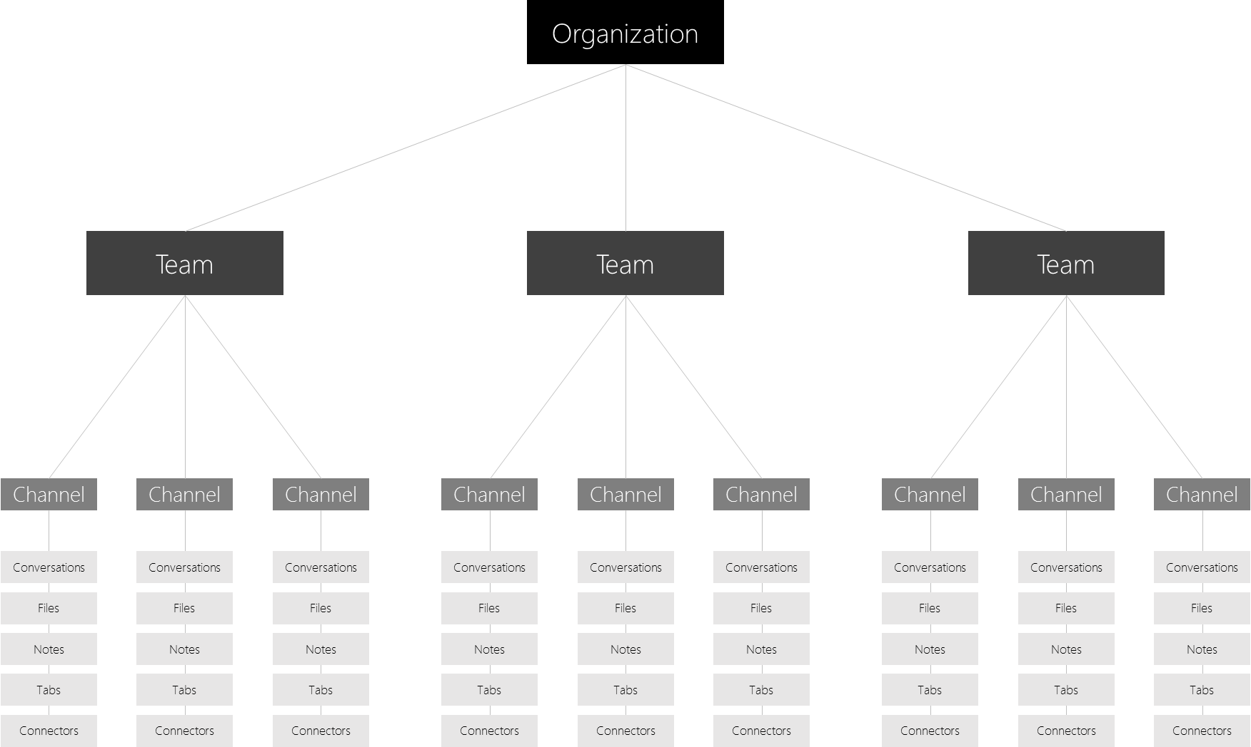

Team Membership

When Microsoft Teams is activated for your entire organization, designated team owners are able to invite any employee* they work with to join their team. Microsoft Teams makes it easy for team owners to add people in the organization based on their name.

Team owners can also create a team based on an existing Office 365 Group. Any changes made to the group will be synched with Microsoft Teams automatically. Creating a team based on an existing Office 365 Group not only simplifies the process of inviting and managing members, but also syncs group files inside of Microsoft Teams.

*Microsoft Teams does not currently support the ability for users outside of your organization to join teams.

Team Roles

There are two main roles in Microsoft Teams: a team owner, the person who creates the team, and team members, the people who they invite to join their team. Team owners can make any member of their team a co-owner when they invite them to the team or at any point after they’ve joined the team. Having multiple team owners enables you to share the responsibilities of managing settings and membership, including invitations.

Team Settings

Team owners can manage team-wide settings directly in Microsoft Teams. Settings include the ability to add a team picture, set permissions across team members for creating channels, adding tabs and connectors, @mentioning the entire team or channel, and the usage of GIFs, stickers, and memes.

As a Microsoft Teams admin, you have access to system-wide settings in the admin center. These settings can impact the options and defaults team owners see under team settings. For example, you can enable a default channel, “General”, for team-wide announcements, discussions, and resources, which will appear across all teams.

2. Deploy Microsoft Teams

Microsoft Teams is available to Office 365 commercial customers with one of the following plans: Business Essentials, Business Premium, E1, E3, and E5. Microsoft Teams will also be available to customers who purchased E4 prior to its retirement. As an Office 365customer, Microsoft Teams is available for your entire organization. Before you deploy Microsoft Teams, there are a few things you should know about the settings in the Office 365 admin center.

Enable Microsoft Teams for your organization

Administrators need to use the Office 365 Admin Center to enable Microsoft Teams for your organization.

1. [Sign in to Office 365](https://portal.office.com/) with your work or school account.
2. Click **Admin** to go to the Office 365 admin center.
3. Navigate to **Settings** > **Services & add-ins**.
4. On the **Services & add-ins** page, click **Microsoft Teams**.  
     
   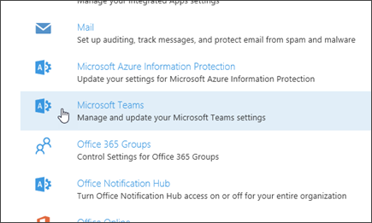
5. On the Microsoft Teams settings screen that opens, set the toggle to **On** if you want to enable Microsoft Teams for your organization, and then click **Save**.  
     
   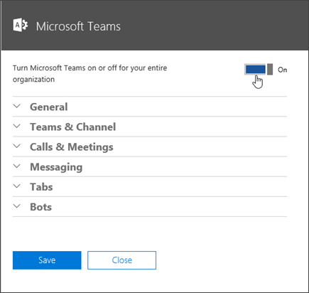

You can control which users in your organization can use Microsoft Teams. By default, Office 365 Group creation is enabled in Exchange Online. But, there are a couple of ways admins can limit the creation of new groups to specific users.

Every Exchange Online user has an OWA mailbox policy that governs what they can and can't do with their mailbox. By using the **Set-OwaMailboxPolicy** cmdlet, you can configure the *GroupCreationEnabled* parameter to be **$true** for users who are allowed to create groups and **$false** for users who are not authorized to create groups. At this time, the only way to update the mailbox policy is through Windows PowerShell.  
  
See [Use PowerShell to manage Office 365 Groups - Admin help](https://support.office.com/article/aeb669aa-1770-4537-9de2-a82ac11b0540) for more information.

**NOTE:** These commands turn off group creation only for OWA and Outlook.

If you want to turn off group creation in your organization, use Azure Active Directory settings. Or, the [General Availability of Office 365 Planner on June 6, 2016](https://blogs.office.com/2016/06/06/microsoft-planner-ready-for-showtime/) provides the opportunity to change the control mechanism to a policy stored in Azure Active Directory. The advantage of this approach is that Azure Active Directory provides a central point that all Office 365 applications can check. After a suitable policy is created, control over the creation of new Office 365 Groups is consistent everywhere. For more information, see the blog post [Controlling the creation of Office 365 Groups using an Azure Active Directory policy](https://thoughtsofanidlemind.com/2016/06/07/controlling-the-creation-of-office-365-groups-using-an-azure-active-directory-policy/).

## **General tenant level settings**

The General section lets you configure the following settings for your organization:

* Show organization chart in personal profile
* Allow email notifications
* Send your diagnostic data to Microsoft and help improve Microsoft Teams

By default, each of these settings are enabled. To disable or enable the setting, toggle the switch to **Off** or **On**, and then choose **Save**.

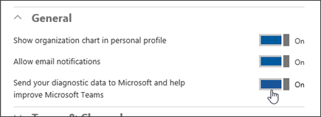

## **Teams & Channel**

A team is designed to bring together a group of people who work closely to get things done. Teams can be dynamic for project-based work (for example, launching a product or creating a digital war room). Or, teams can be ongoing, to reflect the internal structure of your organization. Channels are subcategories of teams. You might create a channel for an activity or for a department. Conversations, files, and notes are specific to each channel, but all members of the team can see them.

As an administrator, you can create and manage team owners and members by using the **Groups** control panel in the Office 365 admin center.

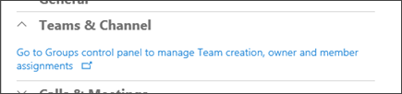

For more information about creating Office 365 Groups in the admin center, see [Create an Office 365 Group in the admin center](https://support.office.com/article/74a1ef8b-3844-4d08-9980-9f8f7a36000f).

After you create a group and assign members, users can create teams by choosing **Teams** on the left side in the Microsoft Teams client, and then choosing **Create team** at the bottom of the client, below the team list.

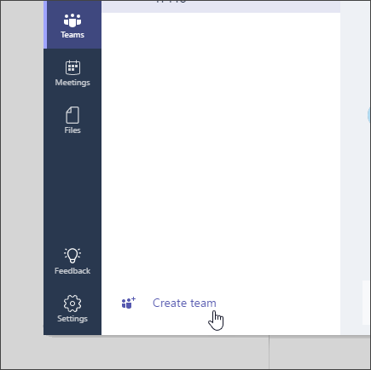

Next, select the option to create your team from a group and associate it with the Office 365 Group you created in the Groups control panel. Or simply add team members by name.

## **Calls & Meetings**

Some companies may wish to restrict the amount of network traffic in their organization. For instance, you may wish to disable video in low bandwidth organizations. The **Calls & Meetings** section lets you choose if users will be allowed to use video or screen sharing during meetings.

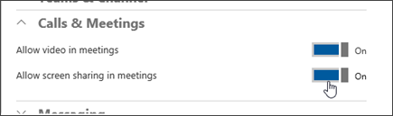

## **Messaging**

As a tenant admin, you can turn on or turn off media content such as GIFs, memes, and stickers in the Messaging section of the Microsoft Teams settings screen.

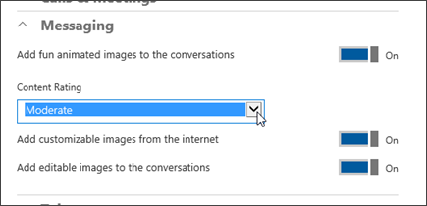

To disable or enable GIFs, toggle the **Add fun animated images to the conversations** switch to **Off** or **On**.

When GIFs are enabled, you can apply a content rating to restrict the type of GIFs that are allowed within the Microsoft Teams in your organization. Content ratings include the following:

* Strict
* Moderate
* No restriction

To disable or enable custom memes, toggle the **Add customizable images from the Internet** switch to **Off** or **On**.

To disable or enable stickers, toggle the **Add editable images to the conversations** switch to **Off** or **On**.

## **Tabs**

Tabs let you customize a channel to include content and capabilities your team needs every day. They provide quick access to frequently used documents and cloud services. In the preview release, there are several built-in tabs such as Files and Notes. In the Microsoft Teams client, at the top of the channel, users can add tabs for Word documents, PowerPoint presentations, Excel spreadsheets, OneNote notebooks, Power BI reports, and plans from Planner.

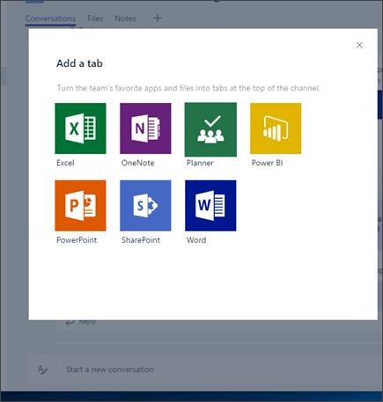

Over time, more tabs will be added, both from Microsoft and from partners such as Zendesk and Asana. Team owners can also side-load tabs so they appear in the Tab gallery for that team. And developers who create LOB applications can also use the side-load capability to test their applications in test teams that they create.

To turn on or turn off support for tabs from partners and support for side-loading of applications, in the **Tabs** section of the **Microsoft Teams** settings screen, click or tap the toggle switch next to **Enable extension tabs in Microsoft Teams**, and then choose **Save**.

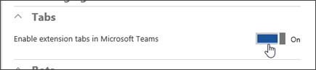

We are launching the developer tools in Preview on 2016/11/2. For more information about building custom apps or integrating an existing tool, go to [Microsoft Teams Tabs Platform](https://aka.ms/microsoftteamstabsplatform).

## **Bots**

Microsoft Teams users can complete tasks such as querying information and performing commands by using bots. You can also integrate your existing LOB systems with Microsoft Teams by using a bot.

For now, only the built-in help, support, and FAQ bot, T-Bot, is available. Note, T-Bot is a part of the product’s help system and cannot be disabled. Additional 3rd party bots are coming soon.

To turn on or turn off the built-in bots, in the **Bots** section of the Microsoft Teams settings screen, click or tap to switch the toggle next to **Enable bots in Microsoft Teams to help users complete more tasks easily**, and then choose **Save**.

To prevent or allow side-loading of proprietary bots, click or tap to switch the toggle next to **Enable side loading of external Bots**, and then choose **Save**.

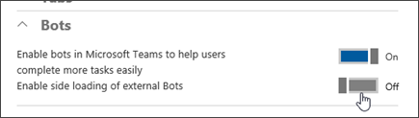

If you’re interested in building a bot, review the [Microsoft Teams Bots Platform](https://aka.ms/microsoftteamsbotsplatform), which has step-by-step instructions for getting started with writing bots for Microsoft Teams.

Note, you must enable bots in order for internal developers to be able to test bots in Microsoft Teams.

**Connectors**

Connectors allow your Microsoft Teams users to receive updates from popular services such as Twitter, Trello, Wunderlist, GitHub, and VSTS.

For more information, see [Connect apps to your groups](https://support.office.com/article/ed0ce547-038f-4902-b9b3-9e518ae6fbab) and [Office Connectors Platform](https://aka.ms/microsoftteamsconnectorsplatform).

## **Client distribution**

The setup file for the Microsoft Teams client is an executable that can be downloaded by administrators and end users from <https://teams.microsoft.com/downloads>. End users on desktops may install the application provided they have the appropriate privileges. Admins can also distribute the installer and distribute it through client distribution tools.

End users using mobile devices can download the Microsoft Teams app from the mobile platform’s app store.

Microsoft Teams is available on Windows (Windows 7 and above) and Mac desktop (Mac 10.10 and above). It is also available on iOS v9 and above (iPhone and iPad), Android 4.4 and above, and Windows Phone 10.0.10586 and above. Microsoft Teams supports the web client on Edge 12+, Internet Explorer 11+, Firefox 47.0+, and Chrome 51.0+. Users trying to open the Microsoft Teams web client on Safari will be directed to download the desktop client. Support for Safari will be coming at a later date.

## **Enable or disable Microsoft Teams licenses**

Administrators manage Microsoft Teams licenses by using the Office 365 admin center. You need to be an Office 365 global administrator or user management administrator to manage Microsoft Teams licenses.

If you want to limit the users who have access to Microsoft Teams in your organization or remove a user you want to restrict, you can do so by disabling the Microsoft Teams license for that person or persons. Once the license is disabled, the user(s) will no longer be able to see Microsoft Teams in the Office 365 app launcher and homepage.

You assign or unassign the Microsoft Teams license to users in the same way you assign any other Office 365 Business or Enterprise license. Sign in to Office 365, navigate to the Office 365 admin center, and on the **Users** > **Active Users** page, assign or unassign the Microsoft Teams license for users. See [Assign or remove licenses for Office 365 for business](https://support.office.com/article/997596b5-4173-4627-b915-36abac6786dc) for more information.

## **Microsoft Teams URLs and IP address ranges**

If your organization restricts computers on your network from connecting to the Internet, check out [Office 365 URLs and IP address ranges](https://support.office.com/article/8548a211-3fe7-47cb-abb1-355ea5aa88a2#bkmk_teams). This article lists the endpoints that you should include in your outbound allow lists and Internet Explorer Trusted Sites Zone of client computers to ensure your computers can successfully use Microsoft Teams in Office 365.

3. Launch pilot teams

Before you roll out Microsoft Teams to your entire organization, it is recommended that you begin with 2-3 pilot teams. This will help you refine your launch plan and ensure you are ready for an organization-wide deployment.

Successful pilots also help spread the word about their experiences which generates excitement throughout the organization for the next wave of launch.

Plan

1. Identify pilot teams

Reach out across a few departments to identify 2-3 pilot teams. In order to participate in the pilot, the entire team should commit to using Microsoft Teams as the primary way to communicate with each other and collaborate on projects for at least one week. This gives pilot teams the opportunity to fully understand the capabilities of Microsoft Teams, and identity the best way to integrate it into their workflows.

1. Identify team champions

Identify champions across pilot teams and enlist them to drive adoption of Microsoft Teams. Champions are not only passionate about what they do, but are also excited to evangelize and help their peers to learn more effective solutions.

1. Setup pilots for success

Give champions the flexibility to customize Microsoft Teams for their pilots, while ensuring you maintain control through advanced security and management capabilities in the admin center. Having open settings enables pilot teams to explore everything Microsoft Teams has to offer. You can always adjust settings as teams evolve.

**Launch**

1. **Hold a kickoff meeting with team champions**

The best way to get pilot teams excited about Microsoft Teams is to get everyone together, either in person or virtually. Schedule a kickoff meeting to introduce Microsoft Teams, discuss the pilot program, and get team champions to experience Microsoft Teams. Show the [product tour video](https://youtu.be/bhIzp2tFXYQ) as an overview of Microsoft Teams and the [Onboarding video](https://youtu.be/LTHxsPmc8Wc) to show how to get their team up and running.

1. **Invite team champions to Microsoft Teams**

Start using Microsoft Teams with your team champions as you plan for launch. Communicate important updates regarding launch, capture feedback from pilot teams, answer quick questions, and share success in Microsoft Teams.

1. **Help team champions stage and launch pilots**

Staging Microsoft Teams

Assist champions with the staging of their Microsoft Teams, including team settings, channels, and integrations with 3rd party applications such as Trello, Asana, GitHub, and more. Encourage team champions to seed welcome posts and team resources for users to discover inside the product. It is recommended that you keep initial staging very minimal as to allow users to organically create channels, customize tabs, and add connectors as needed. See the [Teams and Channels](https://www.youtube.com/watch?v=kyXzlnLNLBU) or [Using Tabs](https://youtu.be/mM_iGhuad38) videos created for this purpose.

Launching Microsoft Teams

Team champions are responsible for defining the purpose of their teams, scope of use versus other tools, norms for communicating in the open, and conventions for creating team channels.

As team champions prepare for launch, encourage them to organize a meeting with their pilot team, similar to your initial kickoff meeting. Encourage them to use videos such as this [Productive Conversations video](https://youtu.be/4guKy0jyFrk) to illustrate how Microsoft Teams can help them be more productive together.

Team champions should ensure team members are properly set up to use Microsoft Teams by dedicating time for everyone to sign in, download the desktop and mobile applications, and to start chatting with each other.

**Nurture**

1. **Shift work to Microsoft Teams**

Help pilot teams take off by encouraging champions to shift important conversations, updates, and projects to Microsoft Teams. This will make team members feel confident about making the switch themselves.

1. **Integrate Microsoft Teams**

Bring live updates and data from 3rd party applications and services such as Trello, Asana, GitHub directly into Microsoft Teams. This will save employees time from checking multiple tools to get timely information.

Encourage team champions to share their ideas for custom integrations with 3rd party applications and bots, tailor made for their teams.

1. **Monitor Microsoft Teams**

Share analytics around adoption and usage of Microsoft Teams with team champions, and remind them to share feedback from team members in the “Feedback” channel.

4. Launch to the rest of your organization

**Raise Awareness**

Go beyond pilot teams to let your entire organization know about Microsoft Teams. FastTrack provides IT Admin resources to do this by including resources to help spread the word, such as the Announcement template, Countdown template, Flyer, Poster, and Tips and Tricks emails. Check the [FastTrack website](https://fasttrack.microsoft.com/fasttrack-faq) or ask your Microsoft sales person for these assets.

**Provide Training**

Organize training events and Q&A sessions tailored for specific teams and use cases.

**Enable Innovation**

Collaborate with champions across the organization to identify advanced use cases, including custom integrations and bots to make the most of Microsoft Teams. Consider creating a team for Microsoft Teams champions across the organization to share ideas that will transform the way their teams work together. Share Microsoft Teams feedback via the [User Voice](http://aka.ms/teamspublicfeedback) or via the in-product Feedback link. Engage with other IT Pros in the [Microsoft Teams Tech Community](https://aka.ms/msteamscommunity).